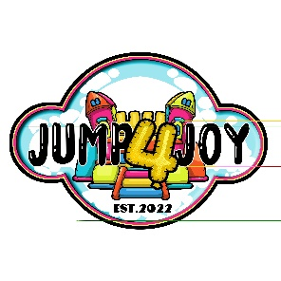

**Preparation Checklist**

Please help us avoid set-up delays and potential problems by checking the following items before we arrive:

Please have the driveway clear of cars and other obstacles when we get there, as well as when we

come back to pick up our equipment.

Please be sure that someone is present at the time of delivery that can show our delivery team

where to set up and make payment of any balance due.

Make sure a clear path of at least 3 feet wide is available for delivery to the set up spot.

Select an open lawn area with enough clearance from tree branches and other obstructions.

The source of electrical power must be NO MORE THAN 50 FEET AWAY. If you are renting more than one item, multiple circuits may be required so as not to overload any one circuit. Please check all outlets to be sure they are working

The set up site should be relatively level, usually no more than an 8 inch slope per 10 feet. We will not set up the Inflatable under or near any electrical or telephone wires. Also, the inflatable cannot be placed near a swimming pool or any body of water.

We use 18" ground stakes to secure our inflatables. Please make sure there are no underground irrigation pipes and/or buried telephone cables or electric lines close to the perimeter of the set up site. The customer is responsible to mark all sprinkler lines and call safe to dig if required by law. **Jump 4 Joy will not be liable for damage to underground sprinklers or utility lines.**

Clear the site of all sharp sticks, animal waste, large rocks and other large debris. Animal waste must be removed.

On hard surfaces like driveways or parking lots, please sweep or use a leaf blower to clean the area.

**Jump 4 Joy reserves the right to refuse rental if we deem the area to be unsafe, an excessive distance away, inaccessible, likely to damage or soil our equipment, or put our delivery crew at risk.**

Jump 4 Joy

860-385-6010

www.jump4joyct.com